**BUG REPORT FOR KNOWORK APPLICATION**

**Bug ID – 1**

**Module name** **–**Register (Portrait Mode)

**Bug description** **–**Page is not fixed.

**Expected Result –** Page must be fixed.

**Bug Image –**

**Bug ID – 2**

**Module name** **–**Register (Portrait Mode)

**Bug description** **–** Login link is not visible.

**Expected Result –** Login link must be visible.

**Bug Image –**

**Bug ID – 3**

**Module name** **–**Register (Portrait Mode)

**Bug description** **–** Hyperlinks are not proper.

**Expected Result –** Hyperlinks must be proper.

**Bug Image –**

**Bug ID – 4**

**Module name** **–**Register (Portrait Mode)

**Bug description** **–** When enter password and Confirm password. Password field and Confirm password is not properly visible.

**Expected Result –** When enter password and Confirm password both the fields should be visible.

**Bug Image –**

**Bug ID – 5**

**Module name** **–**Register (Portrait Mode)

**Bug description** **–** Validation message is not proper for all the fields.

**Expected Result –** Validation message should be proper for all the fields.

**Bug Image –**

**Bug ID – 6**

**Module name** **–** Register (Portrait Mode)

**Bug description** **–** Eye icon is not available in password field.

**Expected Result –** Eye icon must be available for password field.

**Bug Image –**

**Bug ID - 7**

**Module name** **–**Register (Landscape mode)

**Bug description** **–** Pageis not fixed.

**Expected Result –** Page must be fixed.

**Bug Image –**

**Bug ID – 8**

**Module name** **–** Register (Landscape mode)

**Bug description** **–** Password field, Confirm-password field, Hyperlinks, Register and Login links are not visible enough.

**Expected Result –** All the fields in register page is visible to the user.

**Bug Image –**

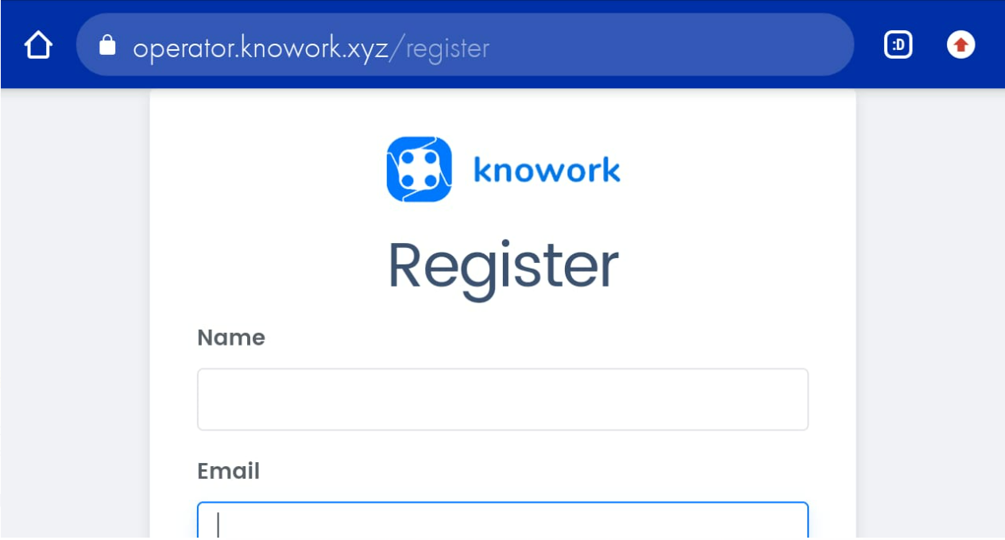

**Bug ID – 9**

**Module name** **–**Register (Landscape mode)

**Bug description** **–** Keyboard is overlapped when all fields are blank.

**Expected Result –** Keypad should not be overlapped when all fields are blank.

**Bug Image –**

**Bug ID – 10**

**Module name** **–** Register (Landscape mode)

**Bug description** **–** When enter Email-ID. Email-ID field is not properly visible.

**Expected Result –** Email-ID field must be visible when enter password.

**Bug Image –**

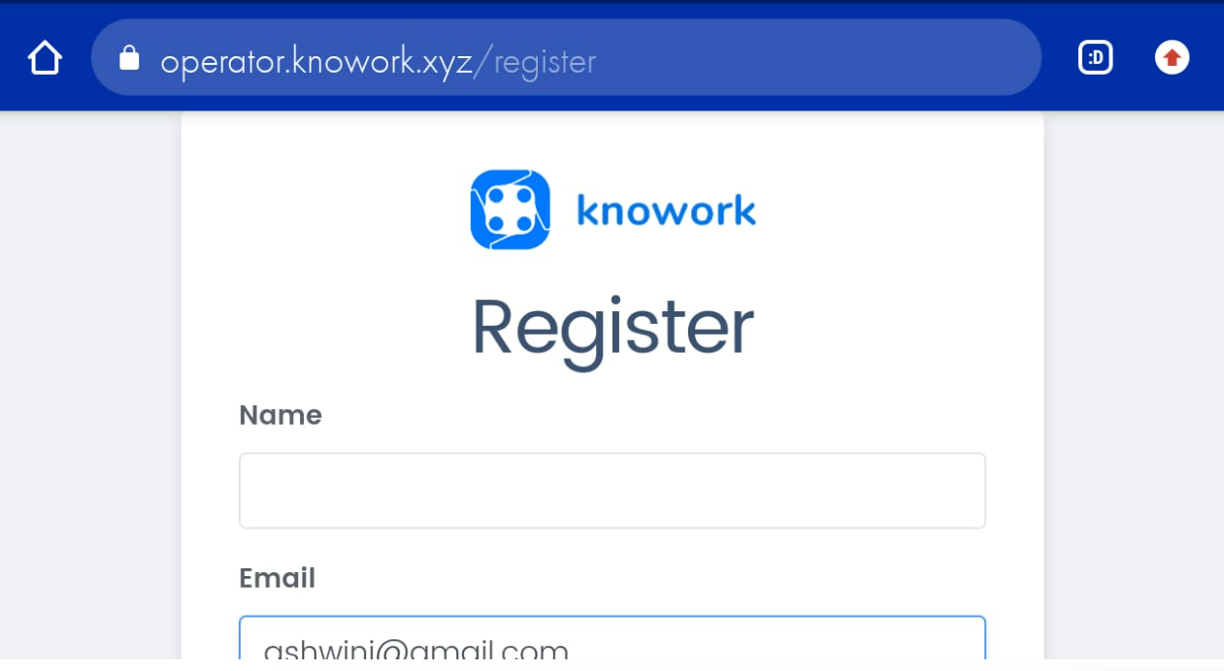

**Bug ID – 11**

**Module name** **–** Login (Portrait Mode)

**Bug description** **–** Page is not fixed.

**Expected Result –** Page must be fixed.

**Bug Image –**

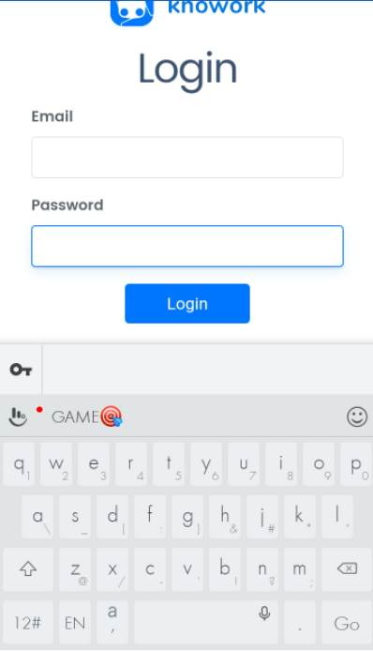

**Bug ID – 12**

**Module name** **–** Login (Portrait Mode)

**Bug description** **–** Validations are not proper are not proper for all the fields.

**Expected Result –** Validation message should be proper for each and every field.

**Bug Image –**

**Bug ID – 13**

**Module name** **–** Login (Portrait Mode)

**Bug description** **–** Register link is too small.

**Expected Result –** Register link must be proper and visible to the user.

**Bug Image –**



**Bug ID – 14**

**Module name** **–** Login (Portrait Mode)

**Bug description** **–** Eye icon is not available in password field.

**Expected Result –** Eye icon should be available for password field.

**Bug Image –**

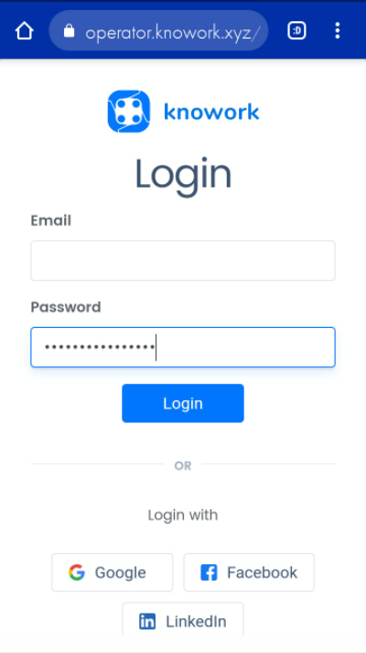

**Bug ID – 15**

**Module name** **–** Login (Landscape mode)

**Bug description** **–** Page is not fixed.

**Expected Result –** Page must be fixed.

**Bug Image –**

**Bug ID – 16**

**Module name** **–** Login (Landscape mode)

**Bug description** **–** Keypad is overlapped when all fields are blank.

**Expected Result –** Keypad should not overlapped for all the fields.

**Bug Image –**

**Bug ID – 17**

**Module name** **–** Create space (Portrait Mode)

**Bug description** **–** Keyboard is overlapped when all fields are blank.

**Expected Result –** Keypad should not be overlapped when all fields are blank.

**Bug Image –**

**Bug ID – 18**

**Module name** **–** Create space (Portrait Mode)

**Bug description** **–** Hyperlinks are not proper.

**Expected Result –** Hyperlinks must be proper.

**Bug Image –**

**Bug ID – 19**

**Module name** **–** Create space (Landscape Mode)

**Bug description** **–** Subdomain field, Logo, Hyperlinks and send button is not visible.

**Expected Result –** All the fields must be visible.

**Bug Image –**

**Bug ID – 20**

**Module name** **–** Create space (Landscape Mode)

**Bug description** **–** Keypad is overlapped when all fields are blank.

**Expected Result –** Keypad should not be overlapped when all the fields are blank.

**Bug Image –**

